LINUX COMMANDS

1. pwd



1. gedit  
     
   
2. cat



1. mkdir



1. cp



1. cd



1. rm



1. rm -r



1. rmdir



1. find



1. touch



1. grep



1. df -m

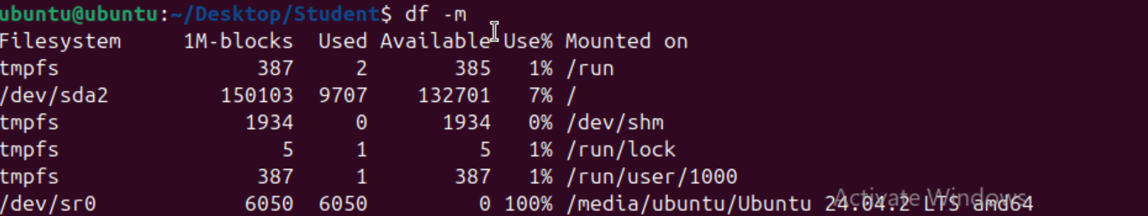

1. sudo

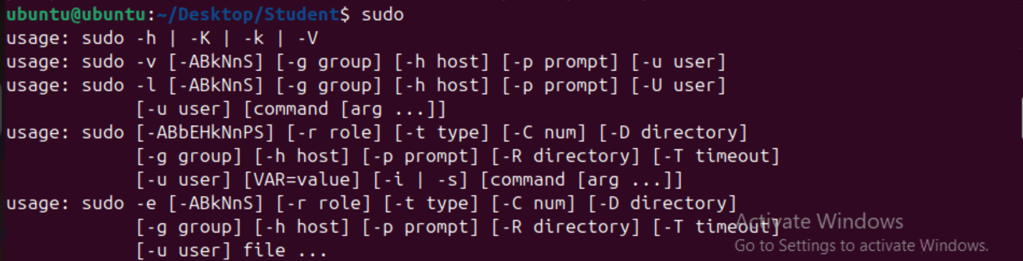

1. sudo apt-get install

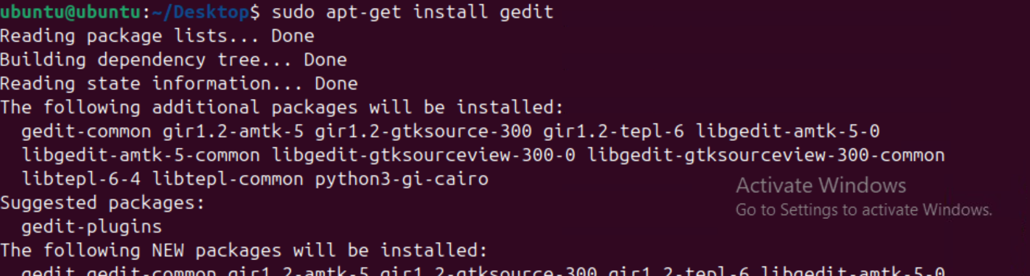

1. chmod --help

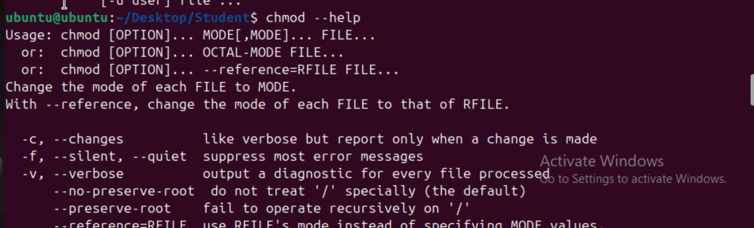

1. wget

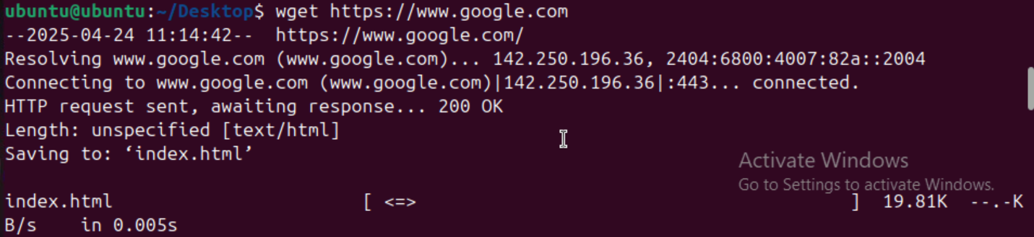

1. tar



Trouble shooting

